Anaconda and PyQt installation Guide

## How to install the Anaconda on Windows

Click on <https://www.anaconda.com/download> will see the following screenshot and just click on Download if you are using Windows 64-bit OS:



More advanced, go further down the webpage and find the following screen and select Anaconda edition accordingly:

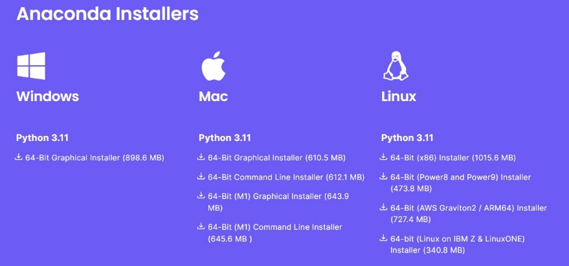

Once the installation completes, go to Windows Starts and find the Anaconda3(64-bit) folder, you should see Anaconda Navigator, Jupyter Notebook, Anaconda Prompt… as in the following screenshot:

If you click on Jupyter Notebook and then just wait a while, the following screenshot will open:

## How to install PyQt with Anaconda Prompt

To install PyQt package just type the following code in Anaconda Prompt:

conda install -c anaconda pyqt and make sure to press enter key:

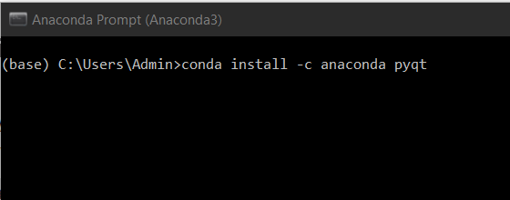

Please be patient, it sometimes takes longer than you expect, depends on your internet connection, if you see the following screenshot, that means Anaconda is busy installation the PyQt package:

Once the installation completes, you should see the Qt Console in the Anaconda Navigator.

### To Open up the Qt Designer, do the following:

1. Click on the Anaconda Prompt

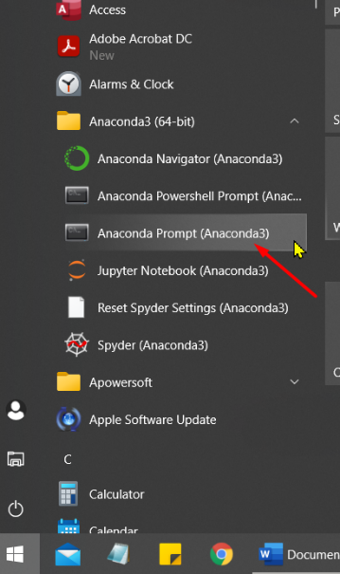

1. Type designer after C:\Users\Admin>

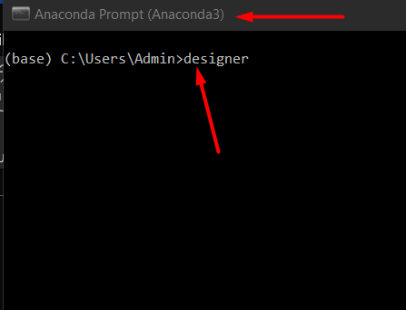

1. Be patient and after a while, you should see the Qt Designer pops up as in the following screenshot

